1. What is API Testing?

1. Mention what is the difference between SOAP and REST?

|  |  |
| --- | --- |
| SOAP | REST |
| * SOAP is a protocol through which two computer communicates by sharing XML document * SOAP permits only XML * SOAP based reads cannot be cached * SOAP is like custom desktop application, closely connected to the server * SOAP is slower than REST * It runs on HTTP but envelopes the message | * Rest is a service architecture and design for network-based software architectures * REST supports many different data formats * REST reads can be cached * A REST client is more like a browser; it knows how to standardized methods and an application has to fit inside it * REST is faster than SOAP * It uses the HTTP headers to hold meta information |

2. API Documentation – SwaggerUI

API: Swagger is a specification for documenting REST API. It specifies the format (URL, method, and representation) to describe REST web services. ... The methods, parameters, and models description are tightly integrated into the server code, thereby maintaining the synchronization in APIs and its documentation.

3. How to integrate excel with rest assured

4. What is the protocol used in your RESTful api?

HTTP Protocol

5. What are the protocol methods?

* GET: Used for retrieving resource data from server.
* POST: Used for creating a new resource.
* PUT: Used for updating an existing resource.
* DELETE: Used for deleting/removing one particular resource.

6. **Can we use GET request instead of PUT to create a resource?**

No, you are not supposed to use GET for PUT.

GET operations should only have view rights, while PUT resource is used for updating a data.

7. **Mention what is the difference between PUT and POST?**

"PUT" puts a file or resource at a particular URI and exactly at that URI. If there is already a file or resource present at that URI, PUT will make changes at that file or resource. If there is no resource or file , PUT will creates the one

POST sends data to a particular URI and expects the resource at that URI to deal with the request. The web server at this point can decide what to do with the data in the context of specified resource

PUT is **idempotent** meaning, invoking PUT at any number of times will not have an impact on resources.

POST is not **idempotent**, meaning if you invoke POST multiple times it will keeps creating more resources.

**8. What is Payload?**

Answer:

9. Explain the caching mechanism?

Ans. Caching is a process of storing server response at the client end. It makes the server save significant time from serving the same resource again and again.

The server response holds information which leads a client to perform the caching. It helps the client to decide how long to archive the response or not to store it at all.

10. Diff JSON Object and JSON Array.

The difference is the same as a (Hash)Map vs List.

**JSONObject:**

Contains named values (key->value pairs, tuples or whatever you want to call them)

* + like {ID : 1}

Order of elements is not important

* + a JSONObject of {id: 1, name: 'B'} is equal to {name: 'B', id: 1}.
  + Starts with {}

**JSONArray:**

Contains only series values

* + like [1, 'value']

Order of values is important

* + array of [1,'value'] is not the same as ['value',1]
  + Starts with []

11. How will you pass the request?

Ans:- PayLoad (JSON File)

The request data which is present in the body part of every HTTP message is referred to as ‘Payload’.  In Restful web service, the payload can only be passed to the recipient through the POST method.

There is no limit of sending data as payload through the POST method but the only concern is that more data will consume more time and bandwidth. This may consume much of the user’s time also.

- we can create payload by using POJO class

12. What is Serialization?

Ans: Java Object --> JSON OBject

i.e: Creating PayLoad

13. What is De-Serialization?

Ans: JSON Object --> Java Object

Data validation Using POJO Class

14. How will you do the data validation in RestAssured (Deserialization)?

Using POJO Class

15. Diff Put & Patch

**PUT** allows a complete replacement of a document of HTTP resource.

A **PATCH** is used to make changes to part of the resource at a location.

That is, it **PATCHES** the resource which changing its properties.

16. What is the framework?

Ans: Cucumber-BDD Framework

17. Status code?

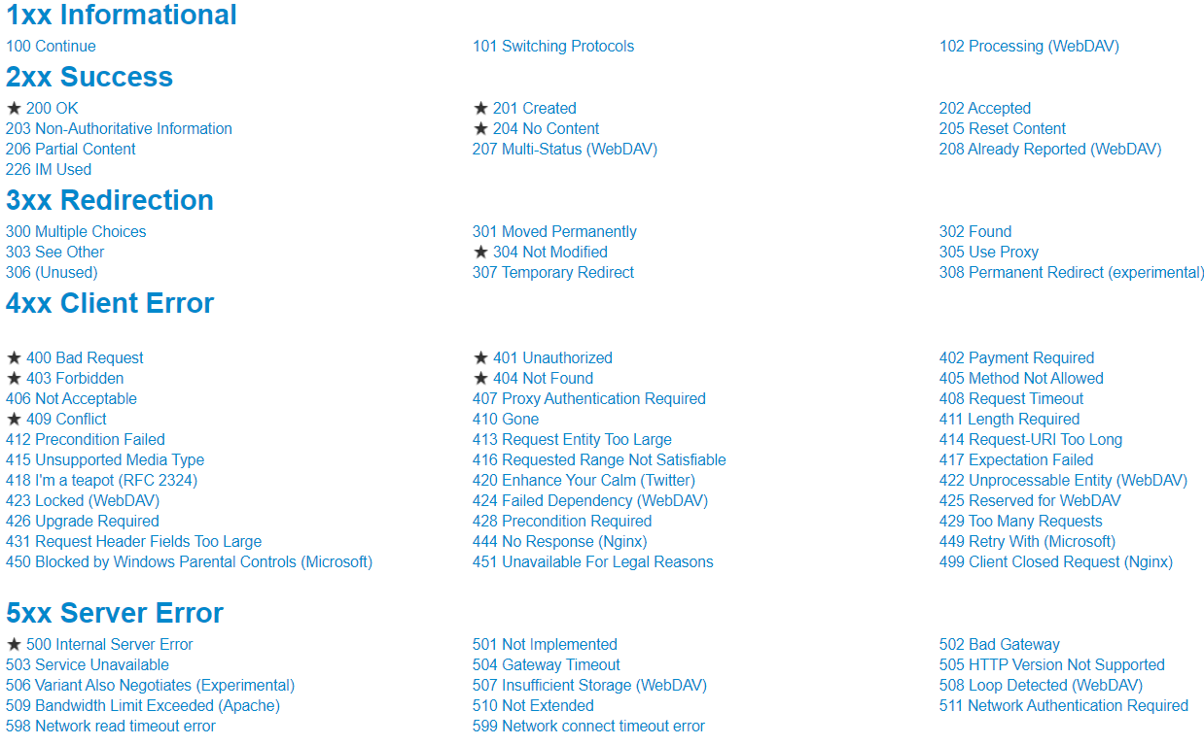

18. Data of an element is not reflecting in application. What is your approach here?

At that time, we can use API Testing in back end.

19.API Challenges

Whenever the requirement has changed ,as per the requirement we will modify and maintaining code for api testing is very difficult begining stage

Api documentation is provided by development team ,sometimes which are not enough to proceed with further so we have to discuss with development team and will update the documentation to proceed the testing.

20.1. Mention the key difference between GUI level testing and API testing?

**GUI Testing**:

Ans. GUI ( User Interface) refers to testing graphical interface such as how user interacts with the applications, testing application elements like fonts, images, layouts etc. GUI testing basically focuses on look and feel of an application.

**Functional Testing:**

To verify the functionality of the application behaves as expected specified in requirement document.

**API Testing:**

While, API enables communication between two separate software systems (client and server). A software system implementing an API contains functions or sub-routines that can be executed by another software system. It is executed in back-end.

21.What are the types of Bugs will API testing finds?

Ans. The types of Bugs, API will find

Missing or duplicate functionality

Not implemented error

Multi-threading issues

Improper errors

22.Mention the steps for testing API ?

Ans. API testing steps

Select the test case that has to be fulfilled

For API call develop a test case

To meet the test case configure the API parameters

Determine how will you validate a successful test

Using programming language like PHP or .NET execute the API call

Allow the API call to return the data to validate

What are the limits of API usage?

Ans. Many APIs have certain limit set up by the provider. Hence, try to estimate our usage and understand how that will impact the overall cost of the offering.

23.What exactly needs to verify in API testing?S

Ans. In API testing, we send a request to API with the known data and then analysis the response.

We will verify the accuracy of the data.

Will see the HTTP status code.

We will see the response time.

Error codes in case API returns any errors.

Authorization would be check.

Non-Functional testing such as performance testing, security testing.

24.What are the differences between API and Web Services?

The API and web services as **means of communication**

1. The only difference is that a web services facilitates the interaction between two machines over a network.
2. All Web Services are API and all API’s are not web services.
3. Webs services is subset of API

25.1.Paramters:

Query parameter-is in key ,value pair

-to define Query parameter we can use ? symbol after the uri

- & symbol is used to split the query parameters.

- we can able to disable it or it might be an optional

Path parameter -to define we can use : symbol

- it is used for specific resource or with sub resources

- we cannot able to disable the path parameter resources

API how it works :

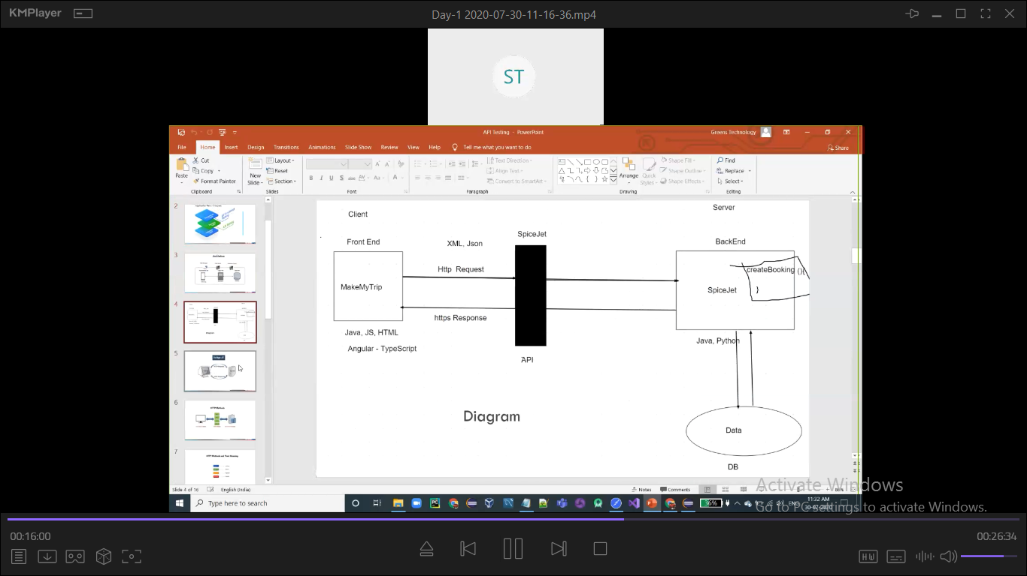

api test case

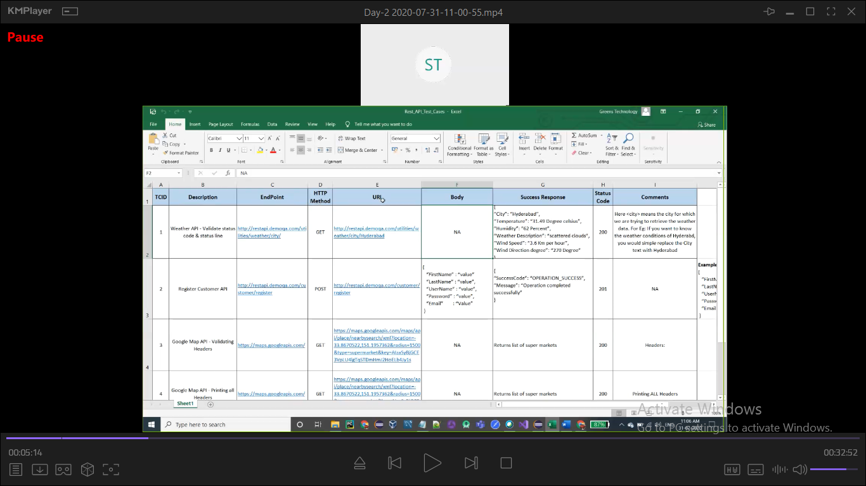

API Documentation

